# Personal description

In this personal description, I am going to briefly explain what I have done for our group. As an Information System student, I use every modeling skills and analysis methods to help others to improve our website. The reason why I choose these documents as my personal portfolio is that all these are the contributions that I made to help other CS students to better understand the main process of our website to improve the functions.

Test case:

Based on the user story to test each functions to make sure each functions match the acceptance criteria. Also provide some suggestions to make some better ideas for CS students to program. Test case takes a long time to implement to test every details of our websites to make sure that we can provide a perfect version for our client.

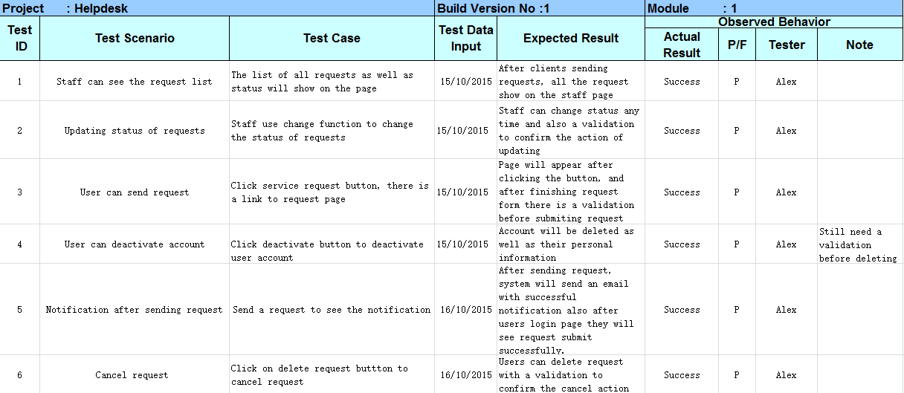

Wrokflow net model:

Based on the modeling skills, by using this model to analyze the process of how our website works, can easily to find which part is the most important part and which part is the basic part. All the functions and process that user and staff will be operated will show on the model. So that CS students can know how to achieve functions in the right way as fast as they can.

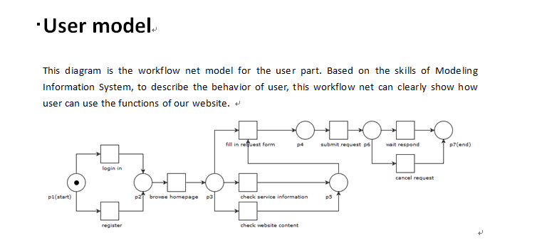

Relationship:

Relationship diagram briefly describe the relationship about three main characters that will involve in our system. This diagram will make us easily understand the scenario and what we need to do and how to implement our website.

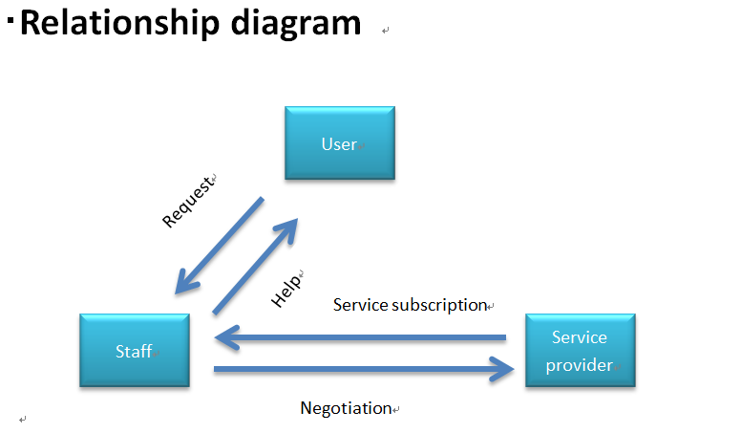

Service information & terms and condition:

I make up all the service information in the user page for user to easily understand what this service is and can get what help. All the information and images take me a long time to find to better indicate what this service is and how to get help.

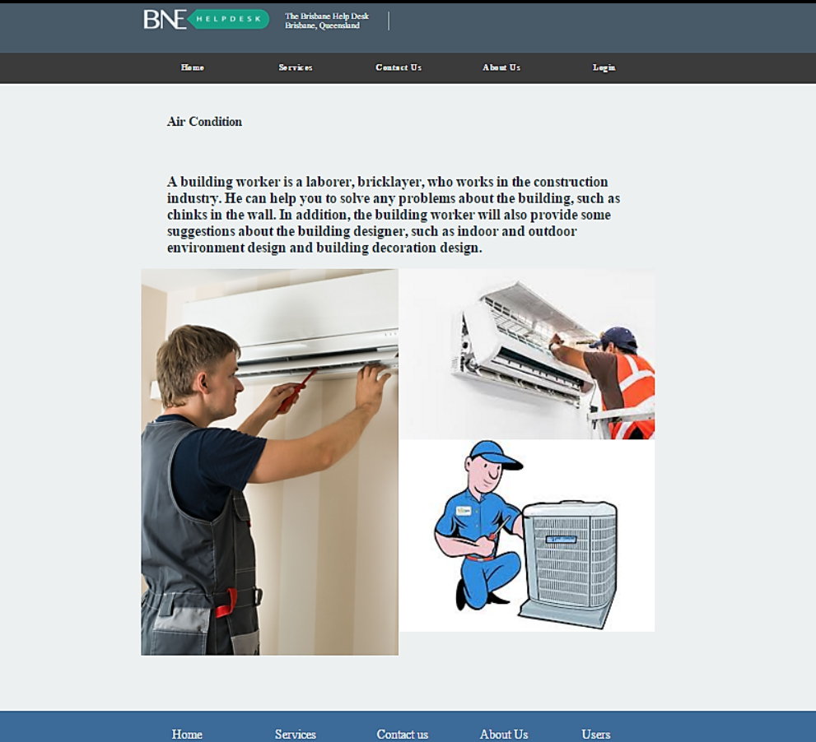

Presentation slides

I make this presentation slides for the final workshop to demonstrate what we have done during the whole project. This will easily show the achievement to our client.

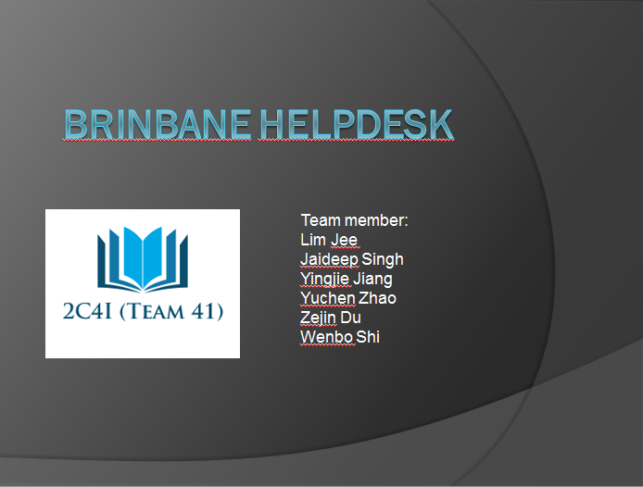

**Peer review:** Providing some advices and editing the peer review.